5. The Genetics of Brassica Rapa

Although natural selection acts on the phenotype, only those traits with a genetic basis can evolve. To see if evolution can take place in your population of field mustard plants, it’s important to determine whether the trait of interest, color, is under genetic control.

1. The non-purple phenotype, is attributable to a recessive allele, anl, or “anthocyaninless” so these plants are homozygous anl. The wild type is the dominant genotype (could be either heterozygous anl/ANL or homozygous ANL/ANL). This corresponds to the intermediate purple plants.

If you were to cross 2 plants, both heterozygous anl/ANL for this trait, you would get the classic 3:1 phenotypic and 1:2:1 genotypic Mendelian ratios in the offspring. (http://www.fastplants.org/activities.variation.monohybrid.php). What kinds of mutations can lead to the absence of a pigment in a plant (think in terms of products of genes and what those products do)?

2. The deep purple phenotype is a different type of mutation altogether, at a totally different locus than anl. This mutation is called Pan (8), the 8, on a 1-10 scale, signifying a high intensity of purple. This allele affects not the presence or absence of a trait but rather the amount of its expression—it is thus said to be quantitative or additive in effect and probably influences the amount of expression of a functional enzyme involved in the synthesis of the purple anthocyanin. Because the amount of expression often depends on environmental conditions, the degree of purpleness varies. When plants heterozygous for this allele are crossed, the expectation is of a 1:2:1 ratio for both phenotypes and genotypes in the offspring. Why?

Answers
1. Under normal situations (the wild type WT), all of the genes responsible for pigment production are operating. For example, light will cause a functional switch to be thrown, which will cause the gene that produces the enzyme that synthesizes the pigment to be turned on (first panel below). Pigmentless mutations often result from rendering an enzyme responsible for production of the pigment defective (the gene for enzyme in the second panel below). It does this by changing the gene that codes for the enzyme. Alternatively, a gene involved in switching on the enzyme gene is disabled by the mutation (genes for switch), so, for example, the switch can’t be turned on by light. Regardless of which type of mutation is involved, if an individual has even one good allele, a functional enzyme will be produced and turned on and the individual will be pigmented. Consequently, the functional allele is dominant over the defective one.
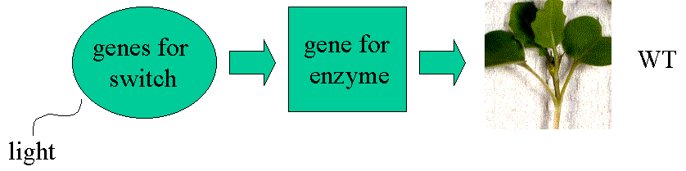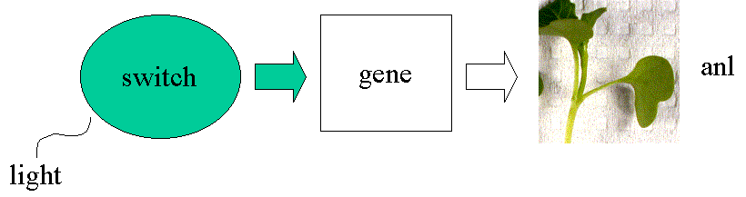

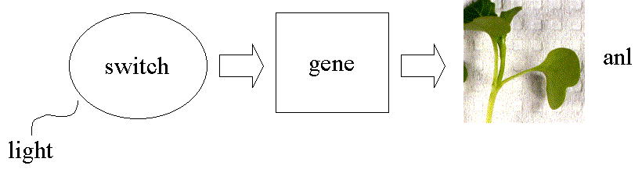

2. No genes are necessarily rendered inactive by this mutation, but it does either affect the switch (causing it to be turned on more often) or, possibly, it causes the gene to produce a more efficient enzyme that results in greater production of pigment. A plant homozygous for the mutation might very well produce more pigment than one that is heterozygous, which will in turn produce more than a plant that is homozygous wild type. Consequently the effects of the alleles are additive and not dominant. Because the effect of the allele is additive, heterozygotes will be intermediate in purplishness between the homozygotes, resulting in three phenotypes, dark purple, intermediate purple, and light purple.

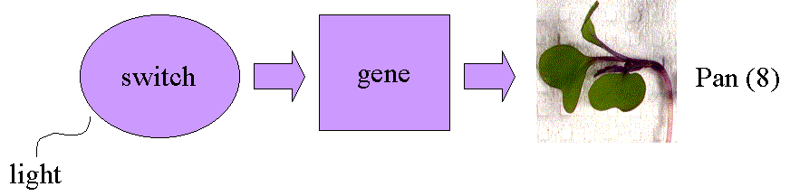

Rate of evolution

There several things to consider when trying to determine what the next generation of plants will look like after our selection experiment. For example, suppose that anl/anl phenotypes are really unfit, even doomed to die early under most conditions. The anl allele can persist for many generations because it is recessive and thus hidden from selection in heterozygous individuals, so although its frequency will decline, it will do so more slowly than an allele that is additive. Take our other mutation as an example,--suppose that any more pigment than what is seen in homozygous wild type plant is lethal, then both Pan(8)/wt and Pan(8)/Pan(8) will be eliminated and there will be no Pan(8) alleles present in the next generation. Of course, our alleles are not lethal, so our changes in allele frequencies, if any, will be less dramatic.

Dictionary sheet:

Gene: segment of DNA on a chromosome coding for a protein or RNA
Allele: alternative state of a gene or trait
Locus: location of a gene on a chromosome
Mutation: change in a gene, either in DNA sequence or in location
Genotype: genetic makeup of an organism
Phenotype: physical appearance of an organism
Chromosome: group of coiled DNA strands containing genes

Genotype X Environment = Phenotype

